**Computer Graphics**

**Lighthouse**



**National Institute of Technology Karnataka, Surathkal**

**Department of Information Technology**

**Group Members:**

Suyash Ghuge 16IT114 Nishant Kumar 16IT123

Dhvanil Parikh 16IT217

**Acknowledgement**

We have made this report file on the topic “**Lighthouse**”. We have tried our best to elucidate all the relevant detail to the topic to be included in the report, while in the beginning we have tried to give a general view about this topic. Our efforts have ended on a successful note. I express my sincere gratitude to Ms. Sangeetha S Harikantra, for giving us this opportunity to develop a project on Computer Graphics. Without this, it wouldn’t have been possible to develop a project in this domain.

**TABLE OF CONTENTS**

1. Abstract 1
2. Introduction 2
3. Requirement 3
4. Methodology 4
5. Result 6
6. Conclusion 7
7. Reference 8

**Abstract**

This goal of this project is to simulate lighthouse and a ship. The idea is taken from the lighthouse on the NITK beach. We will be trying to first depict an image of NITK Beach found in Google Photos in the first phase of the project. In the second phase, we would be trying to show a boat in the sea, which will move according to the user, by keyboard clicks. Also, the Lighthouse would have a beam. The beam would be moving either by itself or by user interaction with the keyboard.A road beside the beach along with greenery will also be depicted. We will be using Line Drawing, Polygon Filling, Scan Line filling, Rotation, Translation and other algorithms to draw and simulate solid figures. The final outcome is expected to be lighthouse with rotating beacon and manual movement of the ships using the keyboard keys with a good background.

1

**Introduction**

This report has been made for the Computer Graphics Project named ‘**Lighthouse**’. This project has been developed to learn, understand and get a hands on experience of OpenGL (Open Graphics Library), a library in C language. Since this a library of C, the project has been on C language, in CodeBlocks IDE. This project is relevant for students to study Graphics and its various algorithms, since Graphics is a major part of today’s modern era. Graphics is applied to various fields such as moveis, games, computers, mobile phones, etc. OpenGL is the basic step towards developing high end graphics used today. Understanding of OpenGL and graphics algorithms would be a building block for a demanding career in graphics. Developing this project would help us in increasing our creativity towards building responsive User Interfaces. User Interface of any application is considered to be its most important part, since everyone first observes the look of any application, rather than the feature that application offers.

2

**Requirements**

**1. Software**

a. Operating System required is Windows / Ubuntu.

b. GCC (C compiler) is required for the code to compile.

c. ‘include’ files required are gl.h, glaux.h, glu.h, glui.h, glut.h.

d. ‘dll’ files required are glu32.dll, glut32.dll, opengl32.dll.

e. ‘lib’ files required are glaux.lib, glu32.lib, glui32.lib, glut32.lib, opengl32.lib.

f. CodeBlocks IDE was used as the development platform.

**2. Hardware**

a. Desktop / Laptop

b. 500 MB HardDisk

c. 512 MB RAM Minimum

3

**Methodology**

**1. Introduction**

This chapter will cover the details explanation of methodology that is being used to make this project complete and working well. The method is use to achieve the objective of the project that will accomplish a perfect result. This project used three major steps to implement project starting from planning, implementing and testing. We would take a look at these three phases one by one.

**2. Planning**

To identify all the information and requirement such as hardware and software, planning must be done in the proper manner. The planning phase has two main elements namely data collection and the requirements of hardware and software. Requirements, both Software and Hardware have been mentioned above.

**3. Implementation**

Project implementation (or project execution) is the phase where visions and plans become reality. This is the logical conclusion, after evaluating, deciding, visioning, planning, applying for funds and finding the financial resources of a project. For this project, there was no requirement of applying for financial resources. The code was implemented in C language, on the CodeBlocks IDE. Initially, the glut files were downloaded and pasted in the specified folders. The planned model was then started with implementation. Since we are portraying NITK Beach. Thus we have drawn a Lighthouse, Beach, Sea, Greenery, Light Beam, Beacon and Road. We have used Scan Line Fill Algorithm to fill the polygons present in the project. We have also used Line Drawing Algorithm and Ellipse Drawing Algorithm to different objects in the project. Boat is formed and placed in the sea, the boat moves when user presses the keyboard left or right buttons. The beam was made to move by itself. Beam moves upto a certain extent at bottom and top and oscillates between the 2 extreme points.

4

**Installation**

This requires a C compiler to run the program. Follow the instruction to run the program:

### **On Windows**

* Open the cbp file with codeblocks.
* Build and run.

### **On Ubuntu**

* To compile the program: gcc lighthouse2.c -lglut -lm -lGL -lGLU -o lighthouse
* To run the program ./lighthouse

### **Resolution**

* The current program runs perfectly in 1366 × 768 resolution.
* Before running the program the resolution can be changed in the program.
* Update SCREEN_WIDTH,SCREEN_HEIGHT according to your screen resolution

**4. Testing**

Code-based testing corresponds to the testing that is carried out on code development, code inspection, unit testing in software development process.

The Code-based testing consists of following testing:

* Dynamic Testing - Statement coverage, Branch coverage, Path coverage
* Checking for Complexity of Code using techniques like Cyclomatic Complexity
* Static Testing - Code Inspection, Code Walkthrough, Code Review, Code Audit

5

**Results**

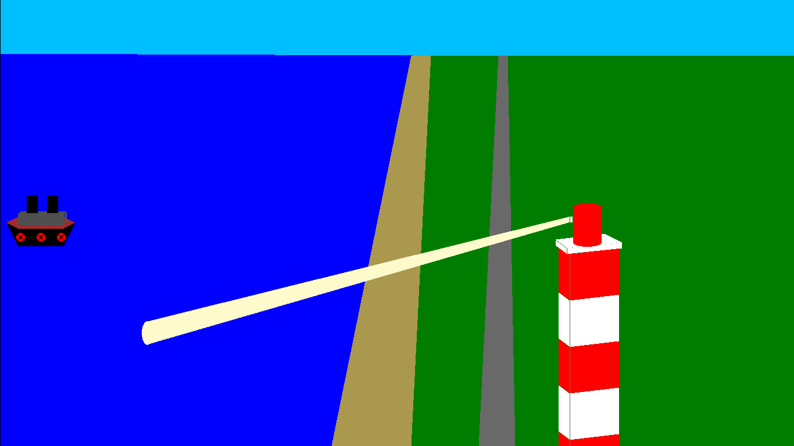

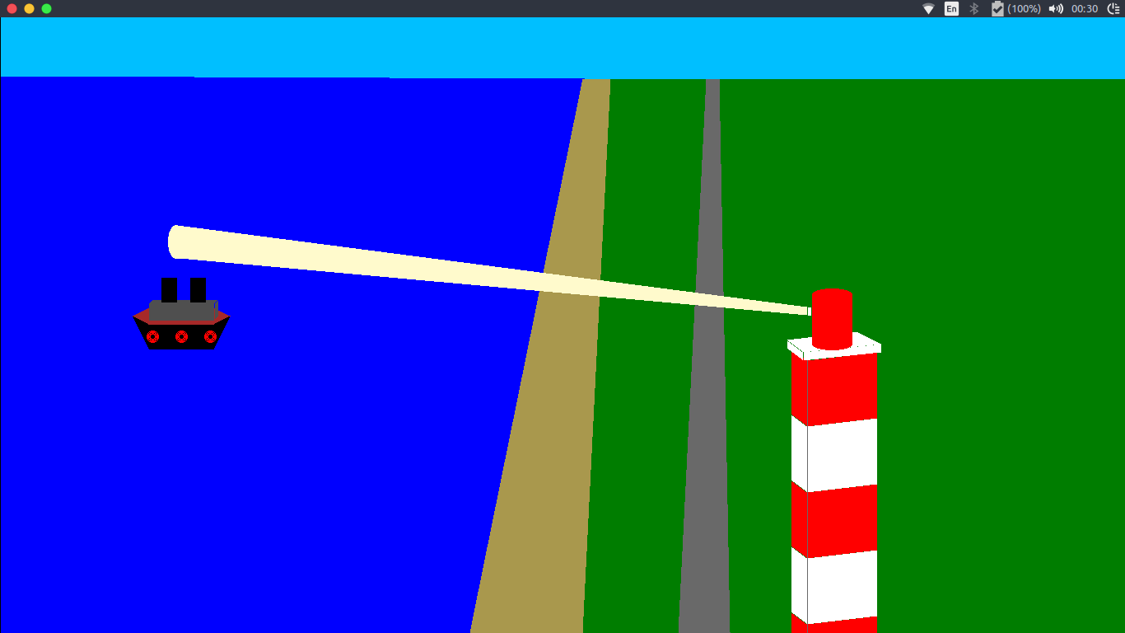

6

**Conclusion**

This report has been made so as to support our Computer Graphics related project ‘Lighthouse’. With completion of this project, many new features and ideas were discovered. We got an opportunity of understanding Computer Graphics theory and applying it practically using OpenGL, thus giving us experience in using this library. While developing this project, quite a few difficulties were encountered, solving which helped us increase our understanding the subject. This project took us various phases of project development and gave us real insight into the world of computer graphics. The joy of working and thrill involved while tackling various problems and challenges gave us a feel of developer’s industry. Along with getting efficiency in computer graphics and OpenGL, the ability to think creatively was also invoked. We would like to thank our respective faculty for giving us an opportunity to work in this domain.

7

**References**

1. <https://en.wikipedia.org/wiki/OpenGL>

2. <https://www.khronos.org/opengl/>

3. <https://www.khronos.org/opengl/wiki/Getting_Started>

4. <https://learnopengl.com/Introduction>

5. <https://www.geeksforgeeks.org/scan-line-polygon-filling-using-opengl-c/>

8